Alex Arnold
Professor Torres
3-4-25
IT 0115-41197
Lab 6

Part A: Netlab3 70-242 lab 1Links to an external site.
Run gpupdate /force on Win10-PCA to see the error.
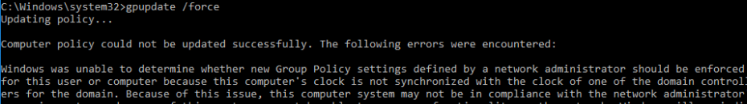
Error message
Fix Win10-PCA error by adjusting the time as a local user on that system
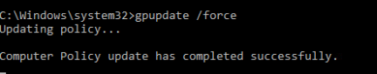
System time changed from west coast to pacific time
Add the below users to the DCA Domain
Superman to Sales-East
Batman to Sales-East
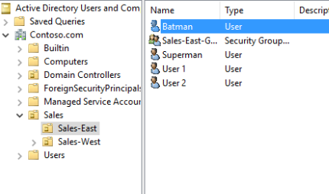
Users added
Wonderwoman to Sales-West
Theflash to Sales-West
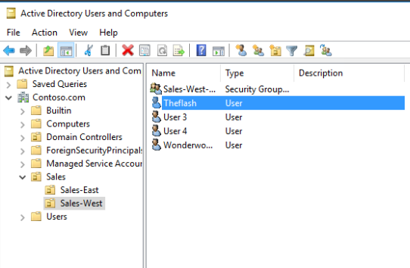
Users Added
Create the OU payroll and add the below user
Thejoker
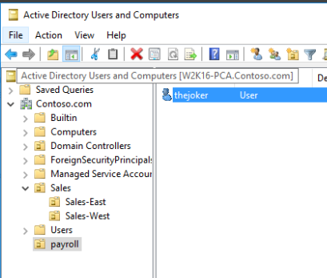
Joker added
Create the OU executive and add the below user
Lexluthor
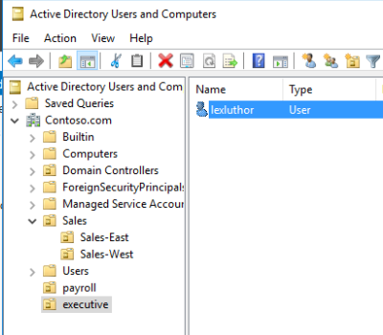
Lex added
Create the OU HR and add the below user
Thepenguin
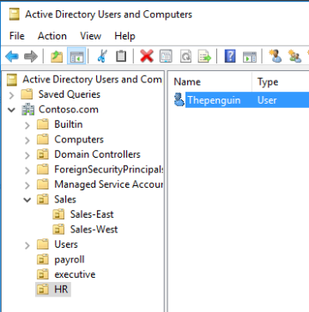
Penguin added

Part B: Netlab3 70-242 lab 1
Create a global password policy with account lockout thresholds (whichever you specify)
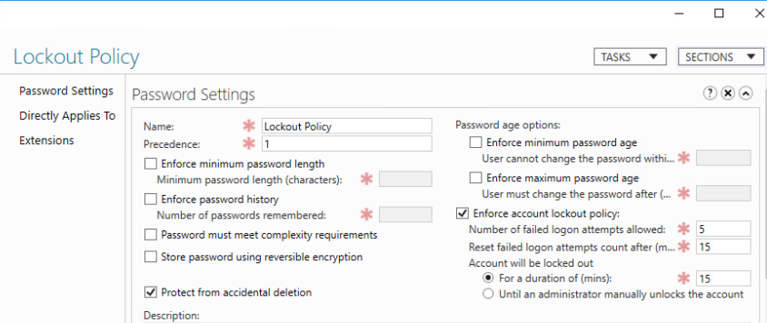
Password policy settings
Create the below policies for the OU’s
Sales-East
Disable control panel access
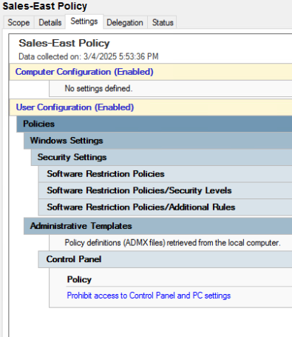
Sales-West
Disable PowerShell access
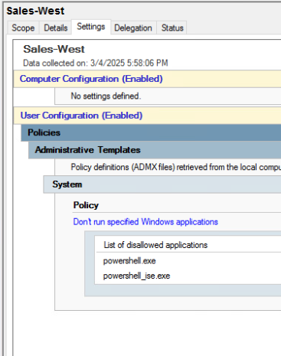
Payroll
Disable task manager access
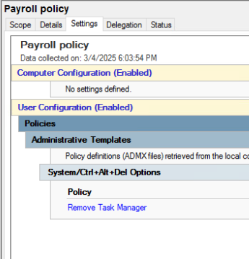
HR
Disable control panel access
Disable task manager access
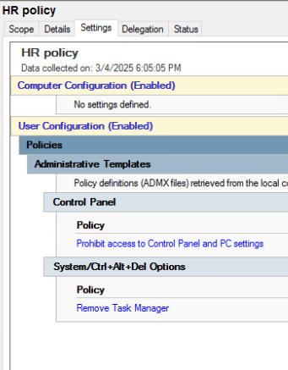
Executive
Disable control panel access
Disable PowerShell access
Disable task manager access
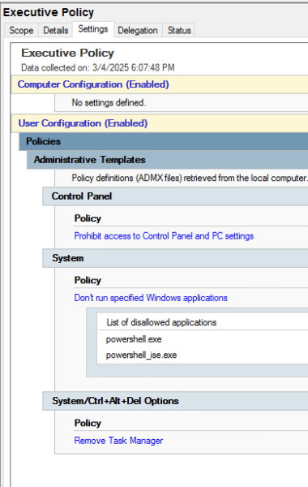
Log on to the PCA as Superman, Batman, Wonderwoman, and the theflash and confirm that the policies are enforced
- Superman and batman could not capture an image as the control panel won’t ropen (nothing to screenshot)
- Same goes for the flash and wonderwoman as you can click on powershell but nothing happens
Log on to PCB as lexluthor, thepenguin, and thejocker and confirm the policies have been enforced
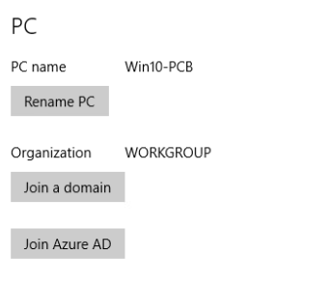
PC-B is not on the domain so it does not get the security policy or the users (also has the wrong ip to join the domain)
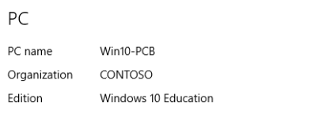
Ip was changed and domain joined

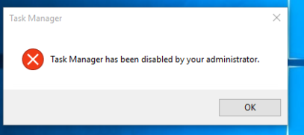
- Lex Luthor policy enforced
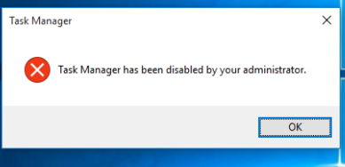
- Penguin policy enforced
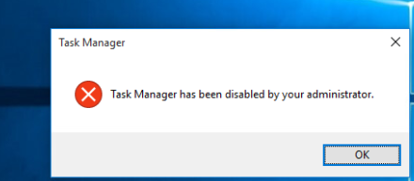
- Joker policy enforced

Part C: Netlab2 NISGTC Linux+ Series 1 Links to an external site.
Log on to NISGTC Linux+ 1 (lab08)
Run all of the commands listed in the lab manual on the Ubuntu Workstation

Log on to NISGTC Linux+ 2 (lab 05)
Run all of the commands listed in the lab manual on the Ubuntu Workstation
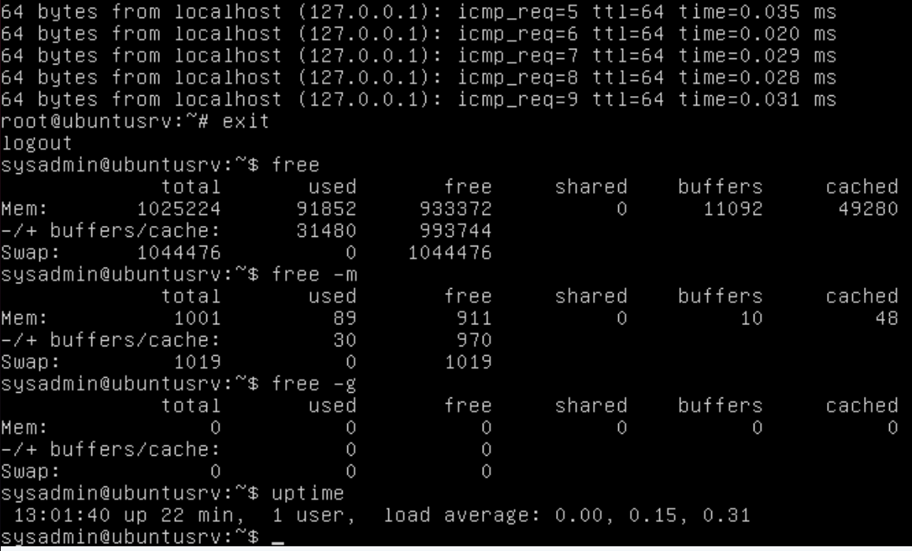
Commands run on ubuntu
Discuss the differences between the commands on Fedora (which is listed in the lab manual) and Ubuntu
The memory available on the machines is different. In the nohup command the output was localhost.localdomain in Fedora where as ubuntu just shortens it to local host. The ping is lusted as pts/1 in fedora and tty1 in ubuntu. Job numbers were different between the machines as well. Other than that the commands are rather simple and standard across distributions so there is not a huge difference between the execution of the commands in Fedora vs Ubuntu.

Part D: NETLAB2 NISGTC Linux+ Series 1
Log on to NISGTC Linux+ 2 (lab 05)
Open the terminal and type the below command:
vimtutor
After you read the tutorial, describe/list the commands to:
exit saving changes
press the escape key to enter normal mode then enter :wq to write and quit
exit without saving changes
press the escape key to enter normal mode then type :q! and press <enter>
how do you copy and paste
start visual mode with v just before the word to be copied then type y to copy the highlighted text. Then move to the new location and type p to paste.
how do you add a line
o will add a new line under the cursor and enter into insert mode
how do you delete a line
type dd to delete a line

